**“ASSIGNMENT NO 1”**



Muhammad Ali

Registration No: 19PWCSE1801

Class Section: A

**Submitted To Sir Rehmat Ullah**

**Date:(27, 11, 2020)**

**Digital Logic Design**

Department of Computer Systems Engineering

University of Engineering and Technology, Peshawar

**2. (10 pts.) Convert (1278.875)10 to its equivalent representation in the following bases:**

**I. Base 16 ____________________**

**II. Base 8 ____________________**

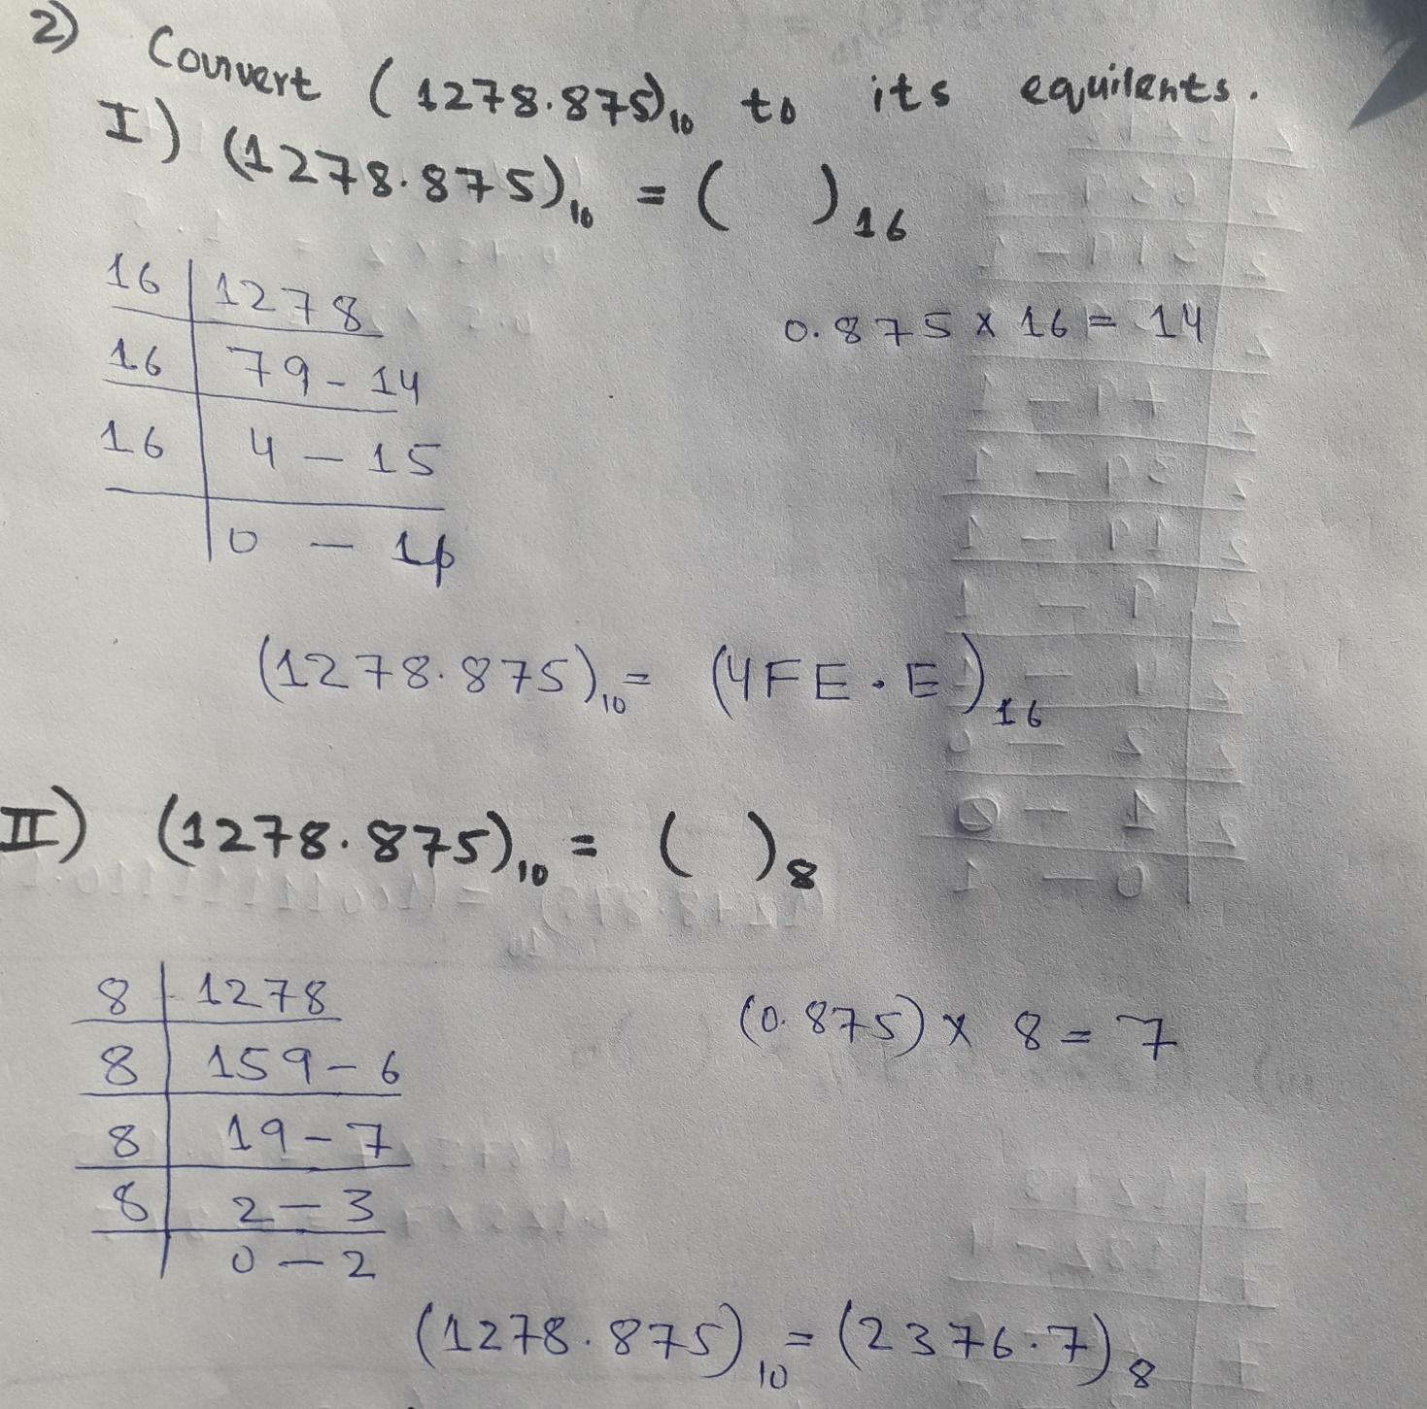

**III. Base 2 ____________________**

**IV. Base 7 ____________________**

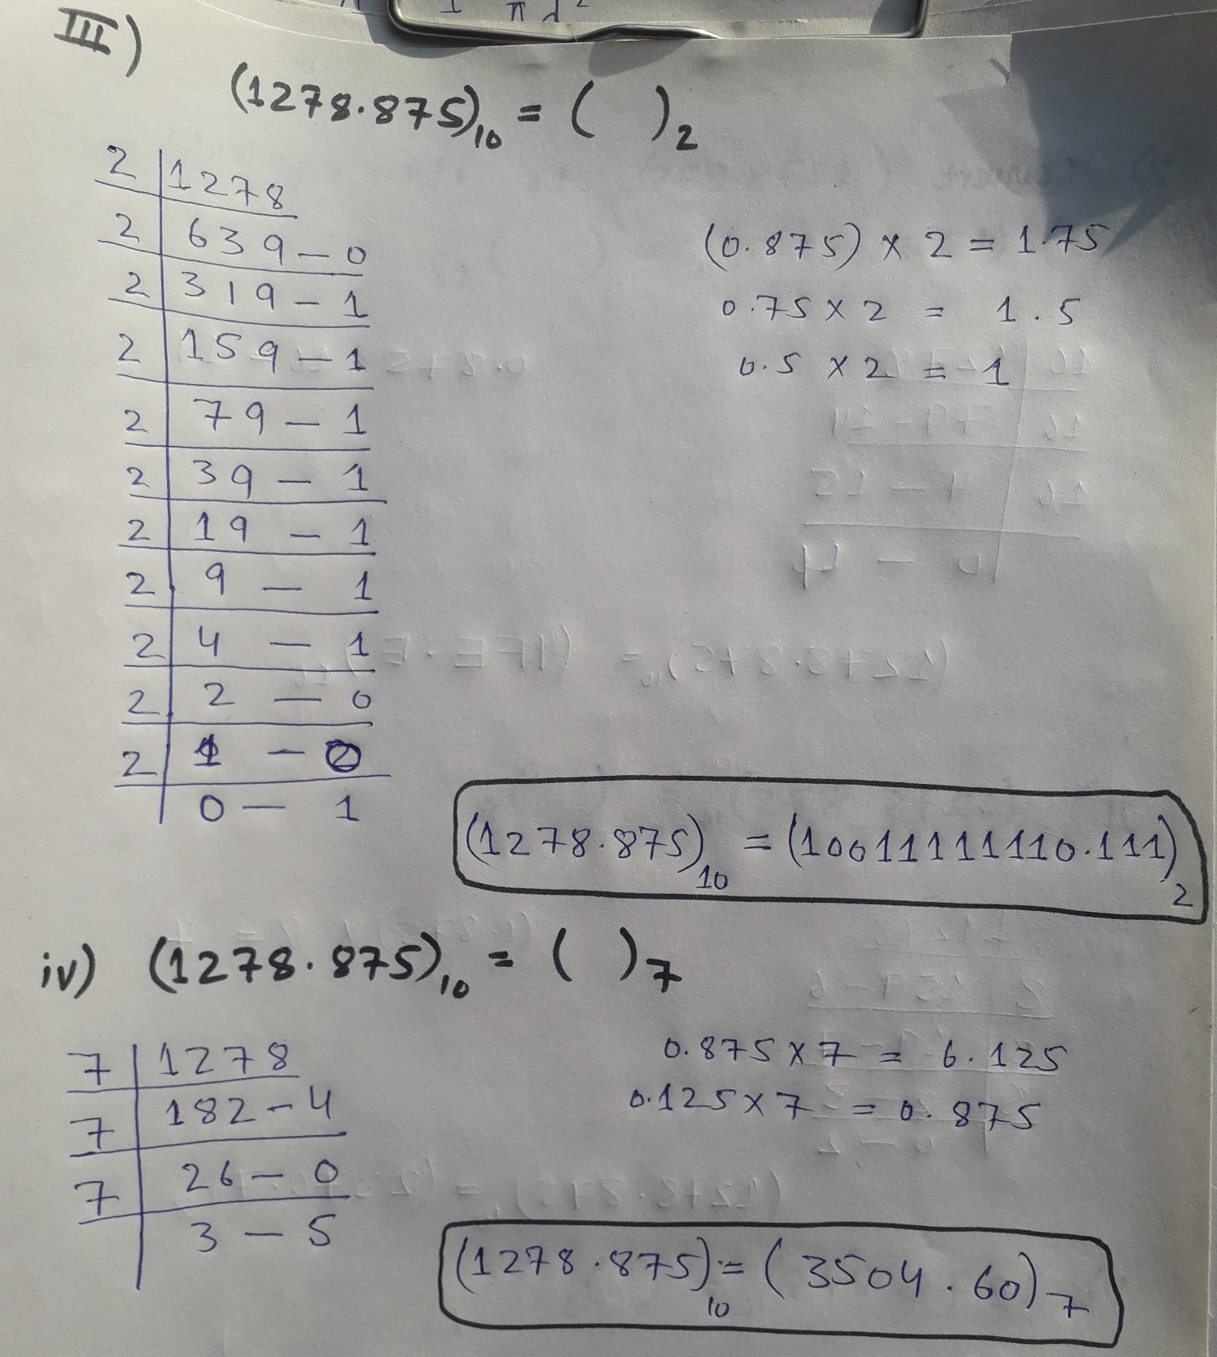

**V. Base 3 ____________________**

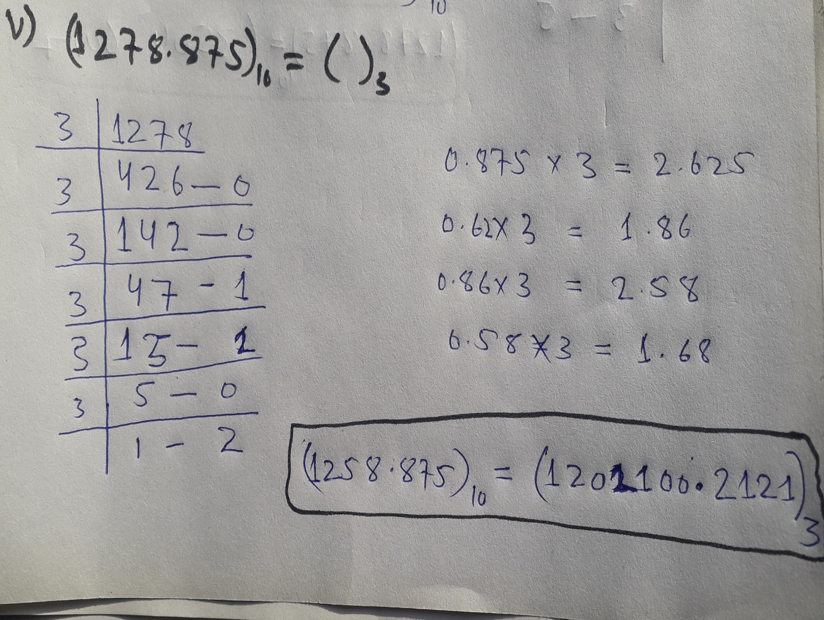

**3. (10 pts.) Find the Base 10 equivalents of the following numbers:**

**I. (3F1B.25)16 _________________**

**II. (456723.75)8 ___________________**

**III. (1011110001110101.10011)2 __________**

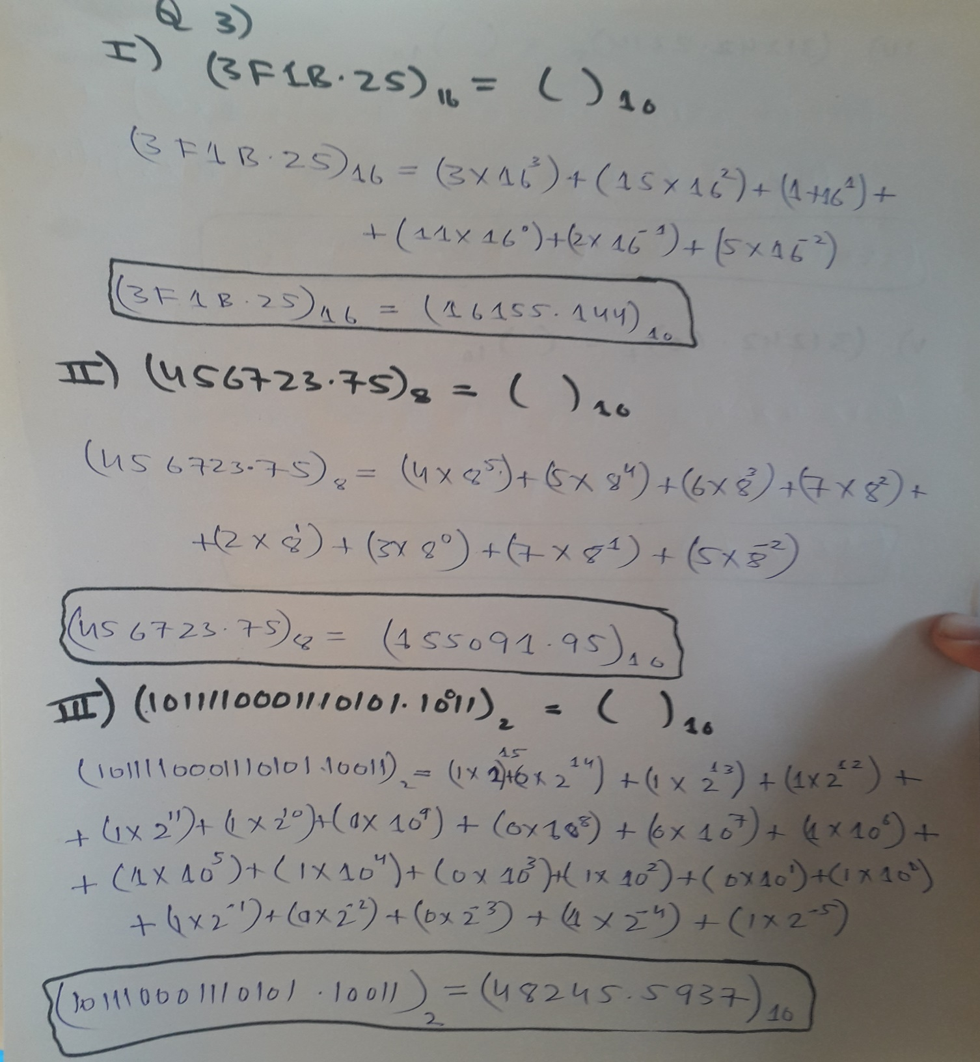

**IV. (31242.2314)5 ___________________**

**v. (31242.60)7 _____________________**

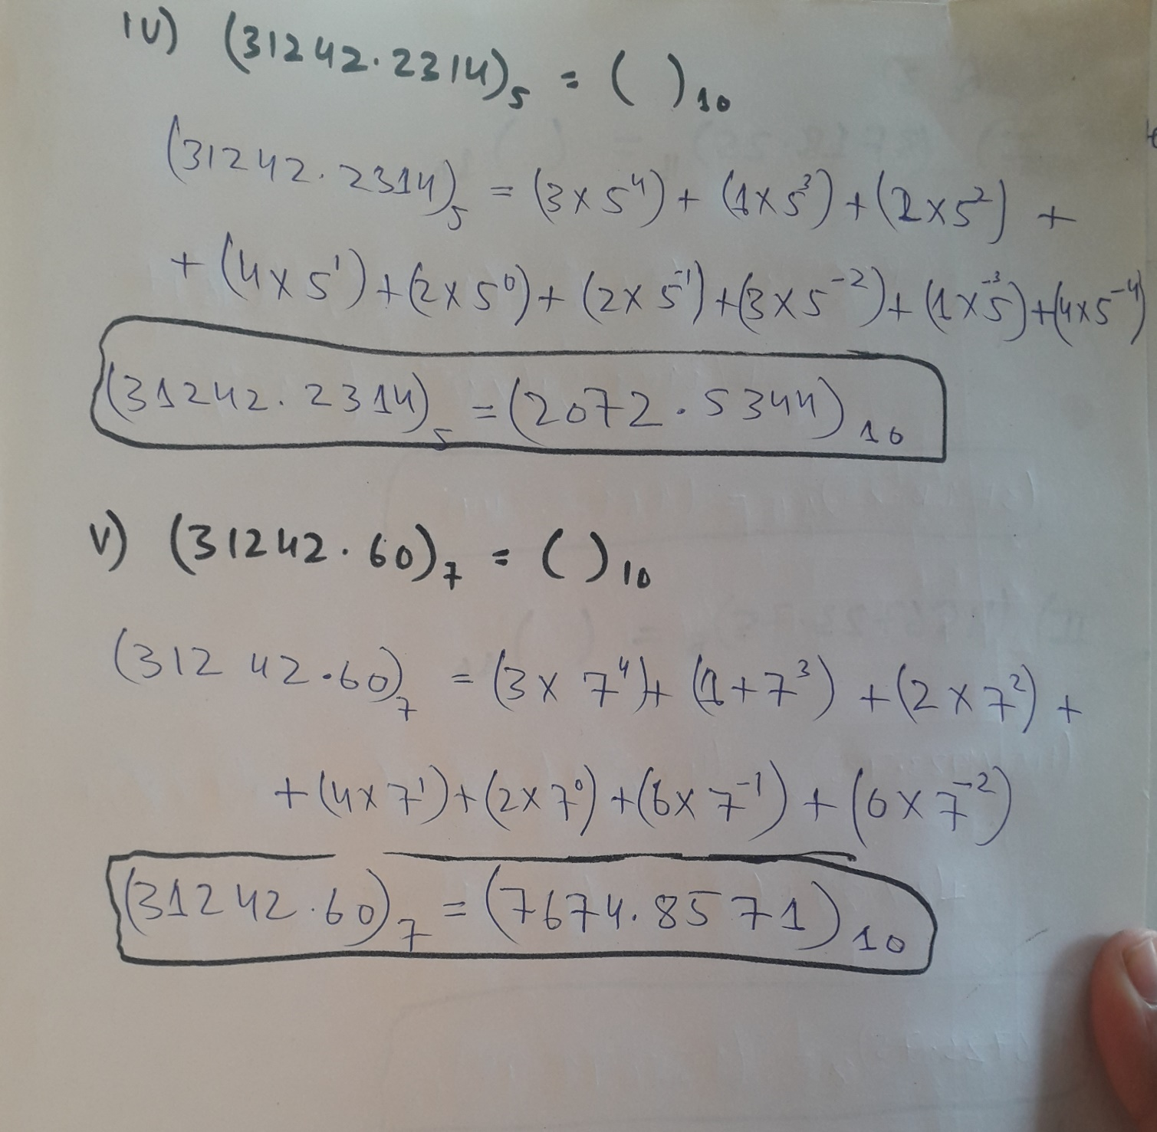

**4. (5 pts.) Convert the following numbers directly to binary without using an intermediary base:**

**I. (3E89.AC27)16 __________________**

Convert each digit to binary in four bits group:

316=00112

E16=11102

816=10002

916=10012

A16=10102

C16 =11002

216=00102

716=0111

**Hence**

**(3E89.AC27)16 = (11111010001001.10101100001)2**

**II. (22144.3561)8 __________________**

Convert each digit to binary in three bits group:

28=0102

28=0102

18=0012

48=1002

48=1002

38=0112

58=1012

68=1102

18=0012

**Hence**

**(22144.3561)8=10010001100100.011101110001**

**5. (5 pts.) Convert (1100110111001010.1011101)2 to:**

1. **Octal ____________________**

**(001100110111001010.1011101)2**

Convert each three bits to octal from right to left at point:

0102=28

0012=18

1112= 716

1102 =68

1002=48

0012=18

**For fraction:**

1012=58

1102 =68

1002=48

**Hence**

**(001100110111001010.1011101)2 = (146712.564)8**

1. **Hexadecimal ___________________**

A16=10102

C16 =11002

D16=11012

C16 =11002

**For fraction:**

B16=10112

A16=10102

**Hence**

**(001100110111001010.1011101)2 =(CDCA.BA)16**

Don’t use an intermediary base.

**6. (10 pts.) Write the first 20 decimal numbers in base 2 (binary).**

|  |  |
| --- | --- |
| **Decimal** | **Binary** |
| 1 | 01 |
| 2 | 10 |
| 3 | 11 |
| 4 | 100 |
| 5 | 101 |
| 6 | 110 |
| 7 | 111 |
| 8 | 1000 |
| 9 | 1001 |
| 10 | 1010 |
| 11 | 1011 |
| 12 | 1100 |
| 13 | 1101 |
| 14 | 1110 |
| 15 | 1111 |
| 16 | 10000 |
| 17 | 10001 |
| 18 | 10010 |
| 19 | 10011 |
| 20 | 10100 |